PROJECT REPORT

ON
Smart Hotel Energy Optimizer
Submitted by:
Muhammad Momin Irfan – 23014119-041
Ayesha Sadiqa – 23014119-157
Romeeha - 23014119-178
Javeriya Aslam – 23014119-181
Department of Computer Science
Semester 6th
Evening – Spring 2026

Technical Report: Smart Hotel Energy Optimizer
Word Count: 1,664 words
Github Repository Link: https://github.com/Muhammad-Momin-Irfan/Energy-Optmizer-Project
Deployment Link: https://energy-optmizer-project-cjygzqwxtnsheg7qzscbhq.streamlit.app
Table of Contents
PROJECT REPORT 1
1. Introduction 3
Overview of energy challenges in hotels 3
Importance of predictive energy management 3
2. Product Design 4
Description of datasets 4
Target users (e.g., hotel managers) 4
System requirements 4
3. Product Development 6
Tools and technologies used 6
Methodology and Data Processing Workflow 6
4. Project Management 13
Risks and limitations 13
5. Conclusion 14
Appendix 15

1. Introduction

Overview of energy challenges in hotels
The hospitality industry is inherently energy-intensive, operating under the unique constraint of maintaining 24/7 guest comfort across expansive commercial real estate. Hotels must provide continuous climate control across vast lobbies, transient corridors, and hundreds of individual guest rooms. Consequently, Heating, Ventilation, and Air Conditioning (HVAC) systems account for approximately 60% to 70% of a hotel’s total operational energy expenditure. Traditionally, facilities management relies on static, scheduled HVAC routines—pumping maximum heating or cooling capacity into a building based purely on the calendar date or external weather, regardless of internal occupancy. This "blind" thermodynamic approach results in massive energy waste during low-occupancy periods. As global energy costs escalate and regulatory bodies enforce stricter carbon footprint mandates, this reactive approach to energy management has become financially and ecologically unsustainable.

Importance of predictive energy management
To resolve these systemic inefficiencies, modern facilities must transition from reactive adjustments to predictive energy management. Predictive management utilizes artificial intelligence to anticipate building energy requirements before the energy is wasted. By accurately forecasting human occupancy and calculating the corresponding physical thermodynamic load of the building's specific geometry, administrators can dynamically throttle HVAC systems. This proactive approach ensures that energy output scales dynamically with human demand. The result is a drastic reduction in utility overheads, a minimized environmental impact, and the maintenance of optimal guest comfort without requiring manual, room-by-room thermostat adjustments.

2. Product Design

Description of datasets
The "Smart Hotel Energy Optimizer" utilizes a dual-model Machine Learning architecture, requiring two distinct open-source datasets to function:
- Hotel Booking Demand Dataset: Sourced from real-world hospitality logs, this dataset contains tens of thousands of historical guest records. Key features include arrival months, length of stay (weekend vs. weekday nights), and demographic guest counts (adults, children, babies). This data is utilized to map the highly non-linear, seasonal trends of human travel and tourism.
- UCI Energy Efficiency Dataset: Sourced from the UC Irvine Machine Learning Repository, this dataset simulates the heating and cooling loads of various building structures. It maps standardized architectural parameters—specifically surface area, wall area, roof area, and building height—against their exact thermodynamic requirements. It is used to establish the maximum physical limits of a given building layout.

Target users (e.g., hotel managers)
The primary target users for this product are hotel General Managers, Facilities Directors, and operational engineering staff. A critical design constraint identified during the user requirements analysis is that these end-users possess deep domain expertise in hospitality, but limited to no background in data science or programming. Therefore, the product must completely abstract all algorithmic complexity. The user simply inputs daily operational metrics (e.g., expected guests, forecast month) into an intuitive, graphical web dashboard and receives clear, actionable energy output directives.

System requirements

Because the product is deployed as a cloud-ready web application, the system requirements for the end-user are exceptionally lightweight, ensuring seamless B2B adoption.
- Hardware: Any standard desktop, laptop, or tablet. The computational heavy lifting (matrix multiplication and algorithmic inference) is handled server-side, meaning no dedicated GPU or high-performance CPU is required on the client machine.
- Software: A modern web browser (Google Chrome, Microsoft Edge, Safari) and an active internet connection. No local installation of Python, libraries, or executable files is necessary, bypassing strict corporate IT installation restrictions.

3. Product Development

Tools and technologies used

The product was developed using an open-source Python data science stack, chosen for its robust mathematical libraries and rapid prototyping capabilities:
- Data Processing: Pandas and NumPy were utilized for dataset ingestion, cleaning, outlier filtering, and matrix mathematics.
- Visualizations: Matplotlib and Seaborn were deployed to generate high-fidelity, color-coded graphs during the Exploratory Data Analysis phase.
- Machine Learning: Scikit-Learn was the primary engine for algorithm training, feature standardization, and model serialization via the joblib library.
- Frontend Deployment: The Streamlit framework was used to rapidly convert the backend Python logic into a reactive, multi-page web application, chosen over Django or Flask to accelerate the development lifecycle.

Methodology and Data Processing Workflow
The development workflow followed a strict, sequential data science pipeline. Because real-world data is inherently noisy, rigorous preprocessing was required before modeling.

Step 1: Data Cleaning and Imputation
The raw hotel booking dataset contained missing values and irrelevant data points. High-noise columns with zero predictive value regarding energy loads (such as travel agency IDs and company codes) were dropped entirely to reduce computational overhead. Columns with minor missing data required careful imputation; for instance, null values in the children column were replaced with the median value (0) to preserve the integrity of the total guest count without fabricating false positive bookings. Finally, statistical outliers (such as highly anomalous 20-person group bookings) were filtered out to establish reliable boundary limits of 1 to 10 guests per room.

Step 2: Exploratory Data Analysis (EDA)
Before training, visual analysis was conducted to uncover hidden distributions. Analysis of the hospitality data revealed intense seasonal clustering, with a massive spike in demand during the late summer months.
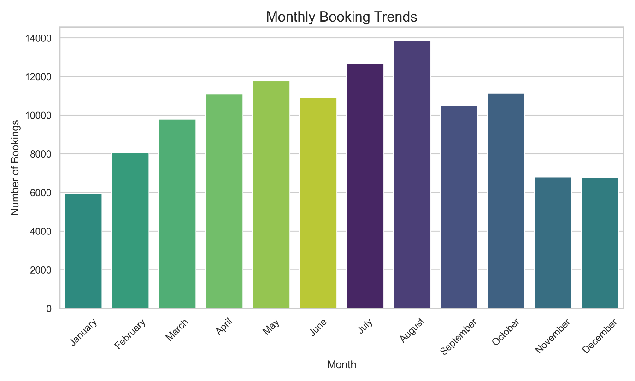

Furthermore, the guest distribution confirmed that the vast majority of bookings consist of 1 to 4 guests, validating our decision to cap the user interface inputs at a maximum of 10 guests to prevent the model from skewing toward extreme edge cases.

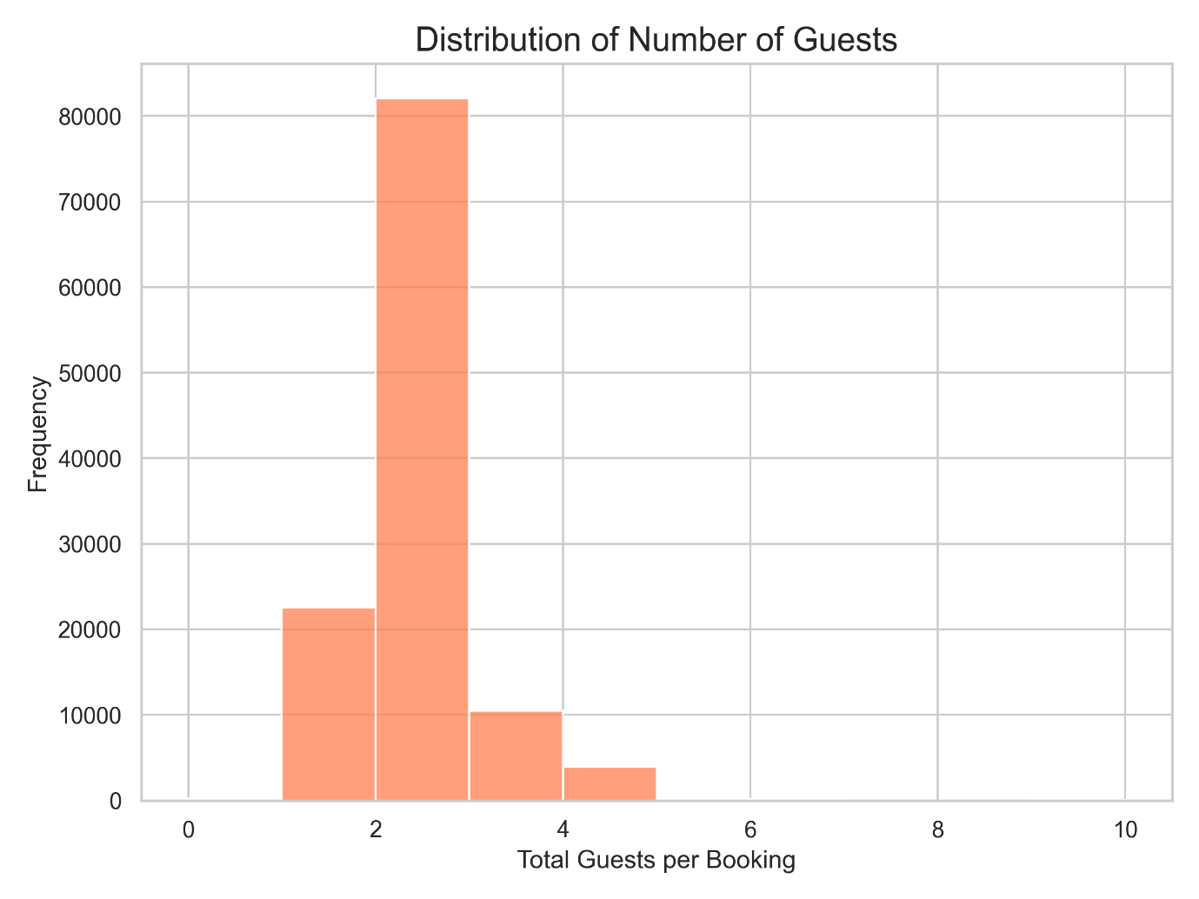

Shifting to the building physics dataset, a correlation matrix was generated to understand how architectural geometry dictates energy consumption. The heatmap revealed that Roof Area exhibits a massive correlation with Cooling Load, aligning with real-world physics where large roofs absorb significant solar radiation.
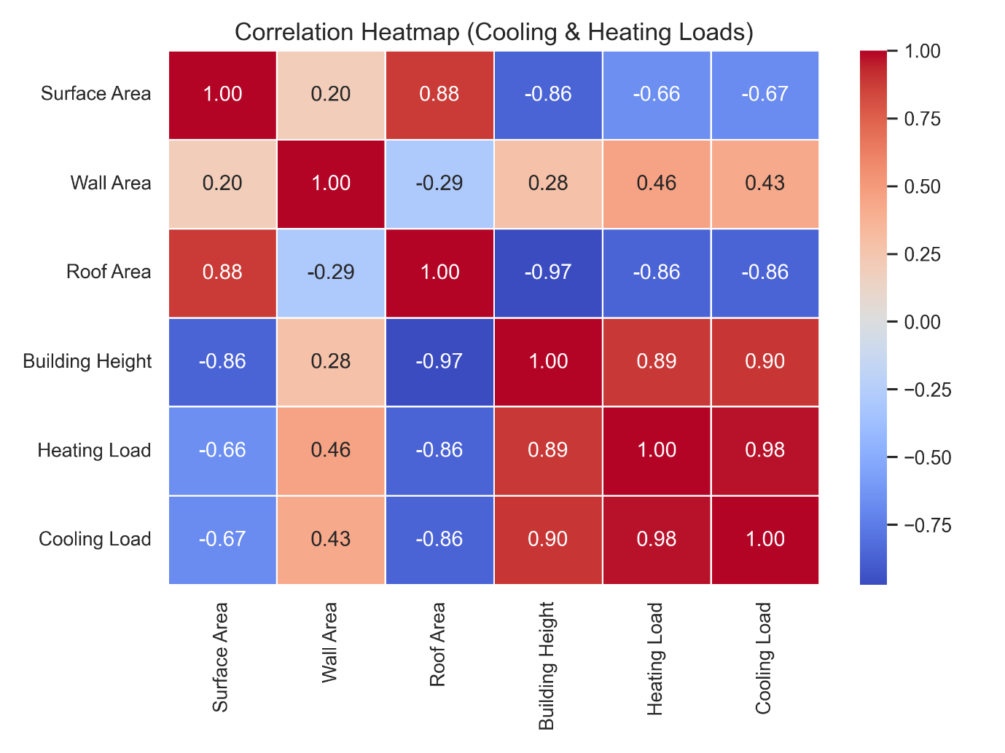
To further investigate, the Heating Load was mapped independently against the four core architectural features using scatter plots. These plots confirmed that the relationships between building geometry and energy load follow distinct, predictable linear trajectories.
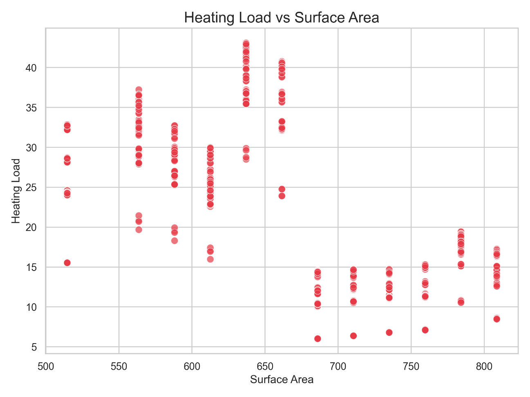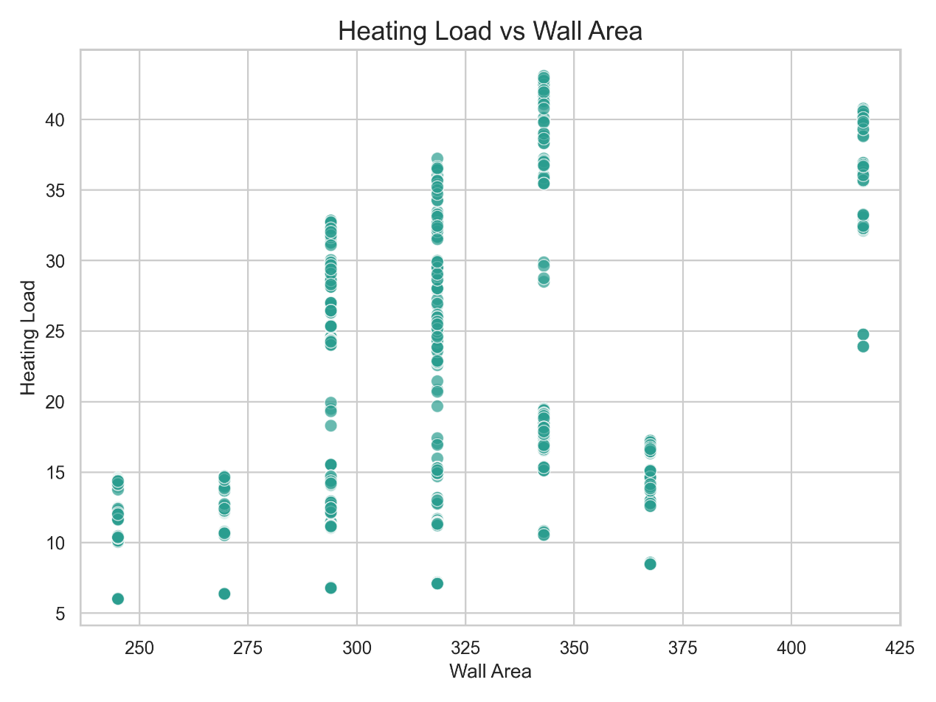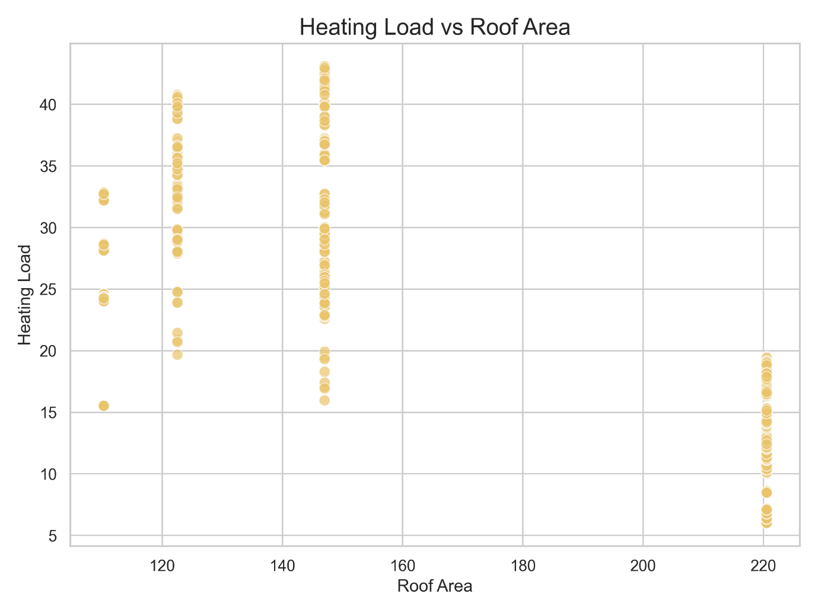
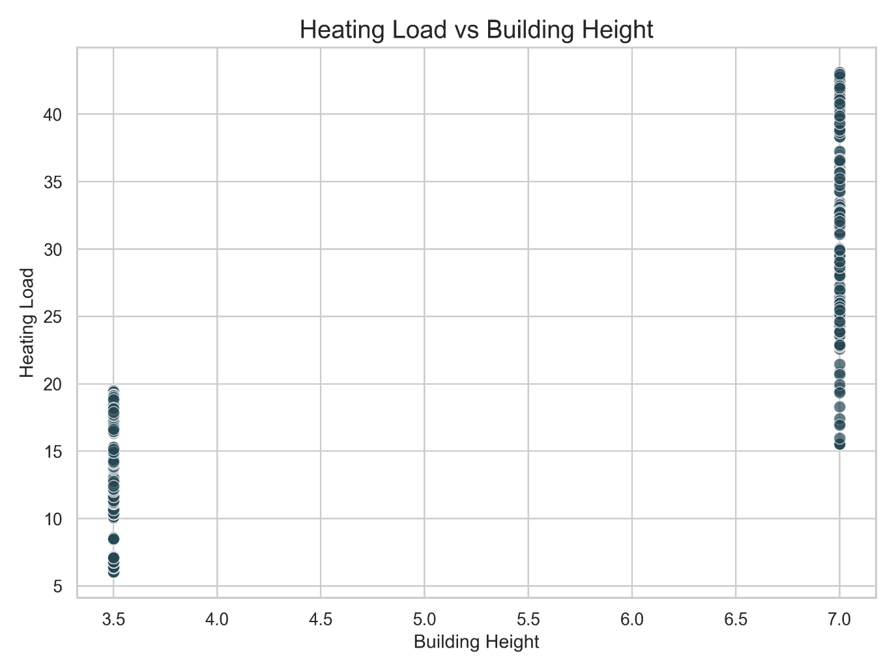
Step 3: Feature Engineering and Scaling
Machine Learning algorithms require numerical inputs. Categorical variables, such as the arrival month, were mapped to numerical equivalents (January = 1, December = 12). For the demand model, an aggregated occupancy_rate metric was engineered, clipping the lowest possible prediction to 0.10 (10%). This serves as a critical safety net representing a hotel's "Base Load"—the absolute minimum energy required to keep pipes from freezing and basic infrastructure running in an empty building.
For the building physics model, the features presented a magnitude variance problem (e.g., Surface Area numbers are massive, while Building Heights are small). Z-score Standardization was applied using Scikit-Learn’s StandardScaler. This centered the data around a mean of zero, transforming all physical inputs into a -2.0 to 2.0 boundary. This guarantees the algorithm evaluates the impact of all architectural features equally.
Machine learning models applied To address the unique nature of both datasets, two distinct machine learning algorithms were deployed:
- Demand Model (Random Forest Regressor): Human booking behavior is complex and highly interactive (e.g., the compounding effect of summer months combined with large guest parties). A Random Forest ensemble algorithm was utilized because it excels at mapping these non-linear behavioral boundaries without overfitting to historical anomalies.
- Building Physics Model (Multiple Linear Regression): As proven by the EDA scatter plots, the relationship between architectural geometry and energy load is governed by strict thermodynamics and is highly linear. A Linear Regression algorithm was applied to the standardized Z-scores to calculate an accurate, baseline thermal load.
These models were mathematically integrated using a custom logic tier. The system calculates the physical "Base Load" of the building, and then throttles that load dynamically by multiplying it against the Random Forest's predicted "Occupancy Percentage."

4. Project Management

Risks and limitations

- Data Privacy & Governance Risk: Hospitality data inherently contains sensitive Personally Identifiable Information (PII) such as payment details and home addresses. This critical risk was mitigated entirely at the architectural level. The application operates strictly on aggregated, anonymized numerical counts (e.g., Month, Guests, Stay Length) rather than individual customer profiles. The system is entirely stateless and does not utilize a backend database to log user sessions, thereby inherently complying with strict data governance laws like GDPR and eliminating the risk of targeted data breaches.
- Algorithmic Drift and Technical Limitations: The current predictive prototype relies entirely on historical dataset averages. It is limited by its inability to account for live, external anomalies, such as sudden, unseasonal extreme weather events (e.g., an unexpected heatwave in November). Over time, as climate change alters baseline temperatures, the model will suffer from "algorithmic drift." Mitigating this in future iterations would require live weather API integration and scheduled, bi-annual retraining of the models to ensure sustained accuracy.
Basic Customer/User relationship management (CRM) For a bespoke data science product deployed to non-technical users, maintaining user trust is paramount. The CRM strategy focuses on seamless onboarding and continuous educational support. The product itself features an embedded "Project Overview" module that acts as a digital user manual, explaining the logic behind the AI in plain language. Future CRM initiatives include establishing a direct feedback pipeline within the application interface, allowing managers to report discrepancies between the AI's daily predictions and their actual monthly utility bills, thereby facilitating supervised retraining of the model.
Potential marketing or real-world applications The "Smart Hotel Energy Optimizer" possesses immense real-world commercial viability as a B2B (Business-to-Business) Green-Tech SaaS (Software as a Service) platform.
- Corporate Marketing Strategy: The system can be aggressively marketed to international hotel conglomerates as an ROI-positive investment. The core marketing narrative highlights that the software requires zero hardware installation or capital expenditure—it simply informs management how to optimize their existing HVAC infrastructure. By demonstrating immediate, measurable reductions in monthly utility bills, the software pays for itself while simultaneously helping corporations achieve lucrative LEED (Leadership in Energy and Environmental Design) certifications.
- Real-World IoT Application: In a fully realized commercial deployment, the product's integration logic could bypass the visual dashboard entirely. The AI's adjusted load calculations could be fed directly via secure REST APIs into a hotel's smart-thermostat IoT (Internet of Things) infrastructure. This would achieve fully autonomous, machine-to-machine building management, removing the need for human input entirely and ensuring perfectly optimized energy usage every minute of the day.

5. Conclusion

The "Smart Hotel Energy Optimizer" successfully demonstrates the powerful intersection of machine learning, building physics, and commercial resource management. By transitioning from reactive, static HVAC schedules to a dynamic, AI-driven predictive model, this project offers a highly viable solution to one of the hospitality industry's most expensive inefficiencies. The integration of a Random Forest regressor to map non-linear human booking behaviors, combined with a Multiple Linear Regression model to calculate strict thermodynamic boundaries, creates a robust and reliable dual-tier architecture.
Furthermore, by abstracting this complex algorithmic logic behind a lightweight, intuitive web application, the product bridges the critical gap between raw data engineering and practical end-user utility. Ultimately, this prototype proves that artificial intelligence can be leveraged not just for digital analytics, but as a direct catalyst for physical energy conservation, significant operational cost reduction, and sustainable commercial real estate management.

Appendix
Appendix A: System Execution Log
The following screenshot demonstrates the successful execution of the complete data science pipeline via a master batch file. This terminal output verifies the sequential execution of data preprocessing, exploratory data analysis graph generation, machine learning model training, and the final integration testing.
